**Website Display Settings for Optimal Viewing**

We hope you are enjoying the new website we developed for you! However, we noticed that the website may not be displaying correctly on your device due to display settings being set to 125%. In order to ensure the website appears as designed and functions properly, we recommend adjusting your display settings to **100%**.  
  
Please follow the simple steps below to adjust the settings:

**Steps to Adjust Display Settings in Windows:**

1. **Right-click** on your desktop screen.
2. Select **Display Settings** from the menu.
3. In the **Display Settings** window, look for the **Scale and Layout** section.
4. Under **Scale**, you’ll see an option that says **Change the size of text, apps, and other items**.
5. Click on the dropdown menu and select **100%** (Recommended).
6. After selecting 100%, click **Apply** to save the changes.
7. You might be prompted to **sign out and sign back in** to apply the settings fully.

## **Screenshot Example of Display Settings:**

Please refer to the screenshot above 👆 for your reference. It shows how your settings should look when adjusted to 100%.

**Additional Step: Check Your Browser Zoom Settings**

Sometimes, display issues can also happen due to your **browser's zoom settings** being more or less than 100%. Please make sure your browser zoom is also set to **100%** by following these steps:

#### **How to Reset Zoom to 100% in Most Browsers:**

##### **Option 1: Using Keyboard Shortcut**

* Press **Ctrl + 0** (zero) on your keyboard.  
  + This will reset the zoom level to 100%.

##### **Option 2: Using Browser Menu**

1. Open your browser (e.g., Chrome, Edge, Firefox).
2. Click on the **three dots (⋮)** or **menu icon** in the top-right corner.
3. Look for the **Zoom** option (usually shows as a percentage like 125% or 90%).
4. Click the **minus (-)** or **plus (+)** signs to adjust the zoom to **100%**.

#### **Screenshot Example of Browser Zoom Setting:**

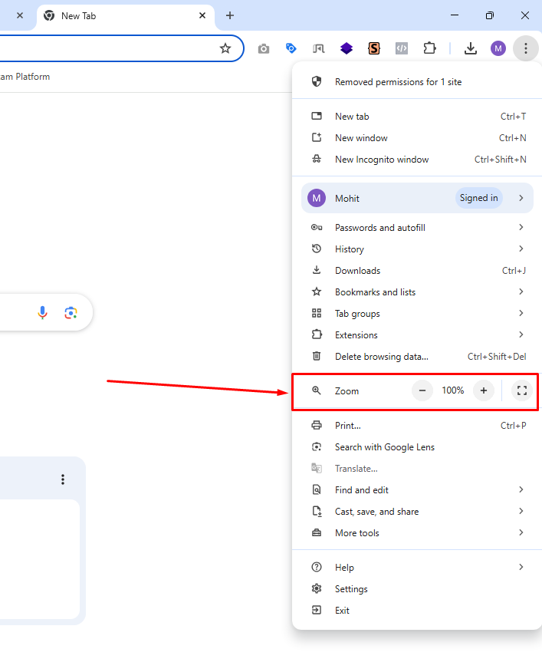

Ensuring **both your system display** and **browser zoom** are set to **100%** will give you the best and most accurate experience of your website design.

## **Why This Adjustment is Important:**

The website was designed with 100% display settings in our mind. When the scaling is set to 125%, it may cause some elements of the website to appear misaligned or out of place. Adjusting the display settings to 100% ensures that all design elements and features will appear as intended.